Economic Data or Fed Talking

* FOMC Wednesday
* Payroll Friday

The SPY ATM Straddle: 508 Straddle $8 implying the SPY can move $8 in EITHER direction

Upside $508 plus $8= $516

Downside $508- $8= $500

Times 10 S&P will move $80 next

WatchList

HTZ 6.21.2024 6 Calls for $.10

ZIM 5.10.2024 15 Calls for $.12

XPO Earnings on May 3rd

Buy the XPO 5.17.2024 120-125 Call Spread for $1.25 debit

Risk: $125 per 1 lot

Reward: $375 per 1 lot

Earnings in AAPL and AMZN

H: Historical Data

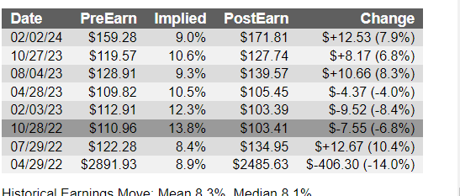

Up 5 of the last 8 quarters

I: Implied Movement: $13.60 or 8%

M: Measured Move Target

$180 plus $13.50= $193.50

$180 minus $13.50= $166.50

C: Bullish to Neutral

The Trade: Buy AMZN 5.3.2024 170-165-160 Put Butterfly for $.45 debit

R: Risk $45 per 1 lot

R: Reward: $455 per 1 lot

B: Breakeven: $160.55 and $169.45

T: Time

T: Target

AAPL on Earnings

H: Historical Movement

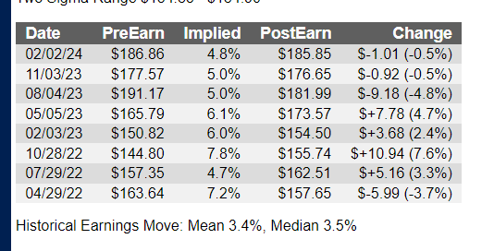

I: Implied Movement: $7.50

M: Measured Move Targets

Upside: $170 plus $7.50= $177.50

Downside $170 minus $7.50= $162.50

The Trade: Sell the AAPL 5.3.2024 170-167.5 Put Spread for $1.20 credit

R: Risk: $130 per 1 lot

R: Reward: $120 per 1 lot

B: Breakeven $168.20

T: Time

T: Target