1. Economic Data for the Week

* Econoday.com 2 us.econoday.com

1. SPY Straddle: ATM Calls and ATM Puts

* Combine them together to see how much the market can move

-Higher the Straddle the Higher the Volatility

3. What hit the Scanner and options in Play

4. Possible Earnings: NFLX, BAC, and UAL

1. SPY ATM Straddle for 4.19.2024

* 510 Straddle is priced at $10, which means the SPY will move in either direction $10, which is 10% of the S&P 500 Futures, so 100 Point Move

1. On Friday, a LOT of Calls being bought in Oil Names, Gold Names, and Resource

>> OptionHacker Signal **2408 SLB 2024-04-26 57.0 Calls $0.657** OI=184 **$54.45 Ref**  
Target #1 $0.99,Target #2 $1.31 (09:47:25 ET)

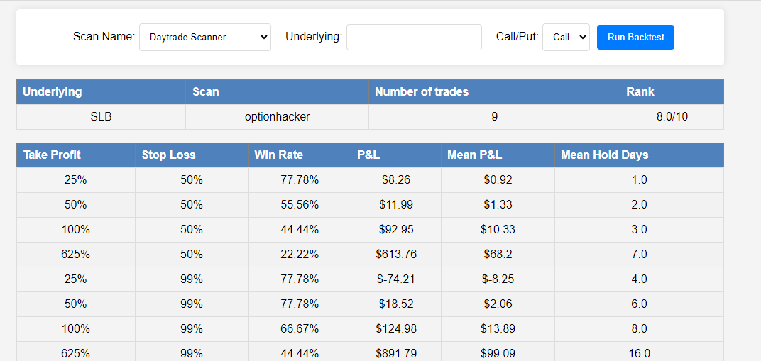

Right now these Calls are “In Play” at $.24

Buy SLB 4.26.2024 57 Calls for $.24

>> OptionHacker Signal **1000 FCX 2024-04-26 56.0 Calls $0.43** OI=433 **$51.59 Ref**  
Target #1 $0.65,Target #2 $0.86 (10:04:30 ET)

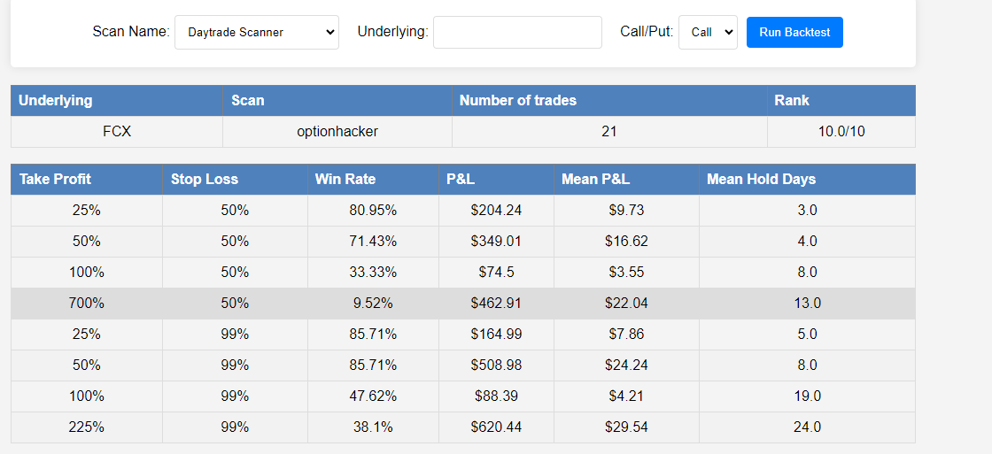

Right now these Calls are “In Play” at $.17

Buy FCX 4.26.2024 56 Calls for $.17

1. NFLX has Earnings Next Week

H: Historical Movement

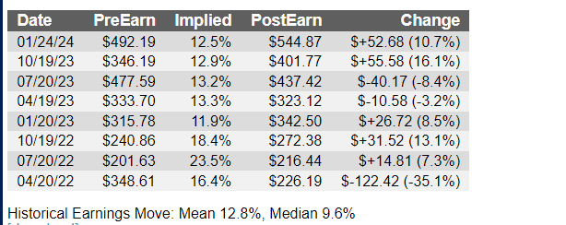

Gone up 5 Quarters, Gone down 3 Quarters

M: Measured Move Target: $55 in either direction

Upside MMT: $622 plus $55= $675

Downside MMT: $622 minus $55= **$570**

C: Very Bullish

Looking to get 4:1 on my money on buying a downside Put Spread

I would buy the NFLX 4.19.2024 575-570 Put Spread for $1.10 debit

R: Risk $110 per 1 lot

R: Reward: $5.00 minus $1.10= $3.90

B: Breakeven: $573.90

T: Time, Next Week

T: Target, $570