>> OptionHacker Signal **2408 SLB 2024-04-26 57.0 Calls $0.657** OI=184 **$54.45 Ref**  
Target #1 $0.99,Target #2 $1.31 (09:47:25 ET)

This trader has the RIGHT but NOT obligation to buy 240,800 shares of SLB between now and 4.26.2024 on the 57 Strike and for that they paid about $130,000

Backtester Results

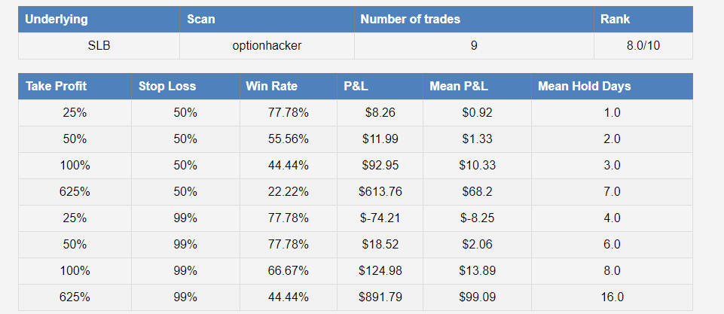

I came in here for AlphaShark Plus and bought the SLB 4.26.2024 57 Calls for $.46

No Stop Loss and Target $.66

So I bought them again for 4.26.2024 57 Calls for $.24

Delta: 13

ATR: $1.13

So on average this option will move $1.13 times $.13 1/3 of three days, 1.5 times next week

I paid $.24, they get to $.36 50% Profits

To get to $.66, they need to move about $3 to the upside

SLB Total for ATM Weekly Money Machine and Calls

Delta: 300, which means every $.10 SLB goes up I make $30, every $.10 it goes down I lose $10

>> OptionHacker Signal **1000 FCX 2024-04-26 56.0 Calls $0.43** OI=433 **$51.59 Ref**  
Target #1 $0.65,Target #2 $0.86 (10:04:30 ET)

This trader has the RIGHT but NOT obligation to buy 100,000 shares of FCX between now and 4.26.2024 on the 56 Strike and for that they paid about $43,000

So I called out a Buy FCX 4.26.2024 56 Calls for $.30

Right NOW worth only $.17

Delta is 9

ATR: $1.38

So once this option will move on average $.09 times $1.38= $.13 1 of 3 days

This trade is a 10 out of 10 on 21 trades over the last 2 years

So I bought more at $.15, to go to $.25, stock only rally a $1