What we have done for YOU

We have added Monday, Tuesday, Wednesday and Thursday 930-950 AM CST 100% FREE to ONLY Education Members

SLOW Walk-Through of ALL the trades for the 1st Hour of the Day

1. Why I took them
2. Why I didn’t take them
3. And More

Technical Analysis

1. Moving Avg Cross LONGS
2. 5 Minute Bar
3. RSI

Scanners: Go through ALL the Scanners

1. Day, Penny, Moon, OptionHacker, Super, Batman, QuickTrade, ShortPut, Superman, and 48 Hour

What to take about TODAY

1. Time Decay: faster on 30 day options

2. Using Stop Losses, when to use them, when to NOT use them

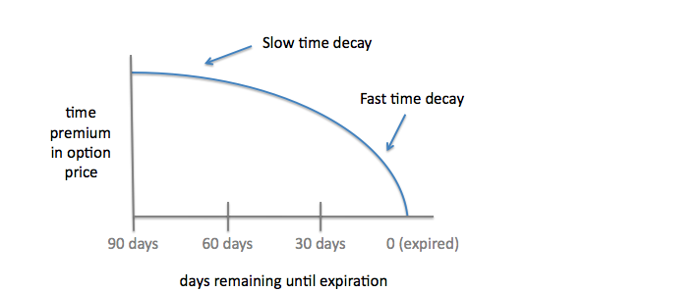

Today I bought the 9.8.2023 28 Calls in MRO for $.21-$.22

DTE: 24 Days Until Expiration, so this option will decay $.01 per day

Vs.

DUK 9.15.2023 95 Calls for $1.20 when stock was trading $93.20

DTE of this was 31

Out of the Money Call with 31 DTE and the option is $1.20 will decay at $.04 a day

A market maker tries to make market, BUT they do NOT want front month premium

Start taking days out of the option to lower the price of the option

Generally, the BEST time to Sell Options or Close Positions is Thursday AM

The Best Time to BUY options is Monday AM or PM, whole week

AK always says that the BEST days to Trade

1. Tuesday

2. Wednesday

3. Monday

4. Thursday

5. Friday

Our goal when trading is to MAKE MONEY NOT put on trades

>> OptionHacker Signal **1178 MRO 2023-09-08 28.0 Calls $0.22** OI=23 **$25.82 Ref**  
Target #1 $0.33,Target #2 $0.44 (10:08:12 ET)

I said to myself I like this in MRO, but I do NOT want to use a stop loss bc I hate selling options for $.10

So I bought 10 options for $.22, also I have to be disciplined and NOT add to this position.

Delta is 20, Gamma is 13

Where would stock move for this option to be worth $.30

$.22 when stock was $25.82

REAL delta is $.33 but theta $.01= $.32 is REAL delta

IF my target is $.30 the option has to go up $.08, so the stock needs to rally,

Which is $.40 higher I would sell that option for 50% Profits

I do NOT like to take options that the DELTA is less than 20.